***Assignment A: New Playful Interaction Concept***

***Come up with a new concept for a social playful interface to encourage positive behaviour***

***within the main THUAS building***

The concept I came up with to encourage positive behaviour within the main THUAS building is some I call study-mood. It is meant to enhance the social cohesion within study rooms. When you enter, you fill in your name and seat on a website. You can choose between several colours: red, blue and green. Red means that you are here to study and nothing else. You don’t want to be disturbed and people around you should be quiet. Blue means that you would like people to accompany you while studying. They can sit next to you and you can study together in silence. If you choose green, this gives of the message that you are looking to socialize while studying, and make new friends, or study together actively, rather than passively like with blue. Once you have filled this out, your seat will turn red, blue or green. Another way how this enhances the studying, is that you can pay extra attention to be quiet is you’re setting next to someone who is red. The system where you fill this in is connected to the chairs. These have LED’s in them to create a hue of the color of your choice.

***Assignment B: Research***

***• Look for a new example of a playful interfaces (that has not been mentioned in class)***

The example of playful interaction I chose, is the shoe customizer that Nike offers on their website. It is so much more fun than selecting a shoe you like, and following the checkout process. This way you can change everything you want about the shoe so it fits your taste. You can check it out for yourself with the following link: <https://www.nike.com/nl/en/u/custom-nike-waffle-one-by-you-10001058/5690438634#Builder>. 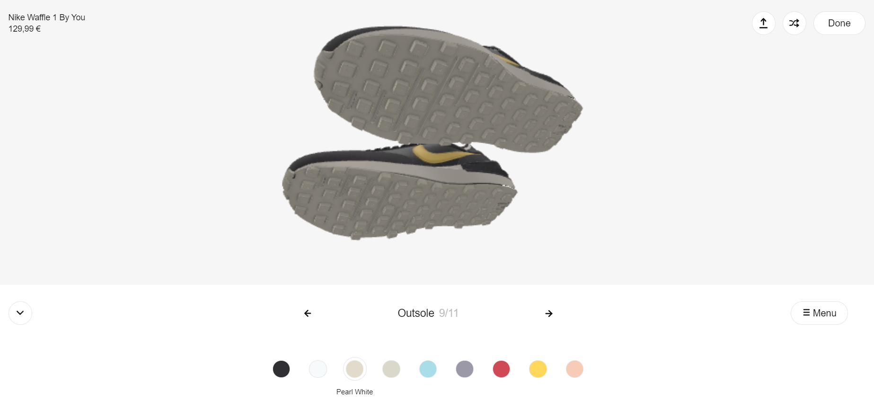

The purpose of this is that the user will walk away with a unique shoe created by them! You have 11 different customizable factors. In each of these 11 steps you can choose to customize this specific part of the shoe. After you choose your shoe, the design is sent to the factory where your custom shoe is made.

***Assignment B: Reflection***

The topic Playful Interaction is one I find really interesting. It is often not that hard to make regular day to day tasks playful, and the payoff is so big! Imagine that the simple act of throwing away thrash becomes fun! Not only can we make it fun for people to do mundane tasks like these, we could also condition people to act a certain way (like throw away your trash), to make the world better. The subject certainly met my expectations!